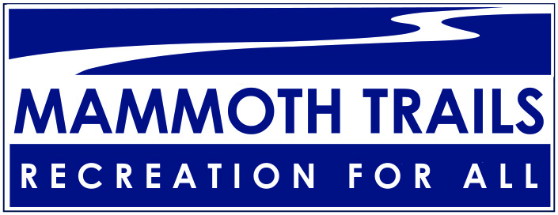

Who We Are

Mammoth Trails started in 2006 as a confederation of user groups convened to address issues among outdoor recreation user groups and provide a cohesive environment for smaller organizations to grow. Today, Mammoth Trails continues to be a collaborative effort to create and enhance outdoor recreation for our community, effectively and inclusively. As partners, allies and friends, Mammoth Trails offers the entire outdoor recreation community a space to share and discover local and regional happenings.

Mammoth Lakes Recreation and Town of Mammoth Lakes convenes Mammoth Trails meetings to engage individuals, groups, agencies, and recreation-based organizations. Participants share resources and engage collaboratively on issues in our outdoor recreation community. Mammoth Trails embraces people and activities that range from moderate to extreme, local to international, and novice to elite. Participants represent the best interests of their individual organizations but ultimately understand the need for collaboration and cooperation within the outdoor recreation community. Task forces or subcommittees may be appointed to provide technical expertise, determine mitigation measures, or garner public comment on specific issues or projects.

What We Do

Recreate | Collaborate | Demonstrate
Have fun!  Go outside! | Share information and resources.  Work together with an open mind. | Equality and inclusiveness.  Commitment to sustainable recreation.

